**BTI225 - Assignment 4 Instructions (30 marks)**

# **Due date**

Friday, March 26, 2021 - 11:59pm

Grade value: 6% of your final course grade

# **Introduction**

This assignment will help you learn and practice interactive DOM programming.

Please do this assignment on your own, and submit only your own work. Gaining experience with JavaScript and the web takes a lot of personal practice, and working on these problems yourself will help build your skill.

# **Instructions**

Complete the code in src/js/index.js to make the table and menus interactive:

* add functionality to all of the stubbed-out functions/methods based on comments in the code.
* make it possible to click on any of the menu items and have the table's contents update to show the requested data. The table takes the following form:
* Flag - an <img> with the flag for the country. All flag images are located in src/flags/ and named according to the country code.
* Code - a string with the country's code
* Country/Dep. Name - a string with the name of the country. This will either be in English, or whatever language the user requests.
* Continent - a string with the continent for this country
* Area (Km2) - a number with the area in square km
* Population - a number with the population of the country
* Capital - a string with the name of the country's capital

All country data comes from src/js/countries-data.js (see this file for format details). The complete array of countries is available via countries.all in src/js/index.js.

Here is an example of what the table might look like:

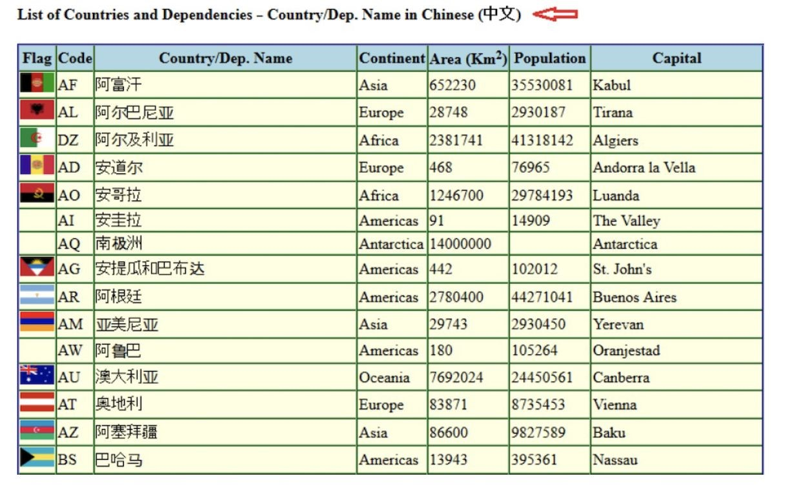

Finally, make sure you update src/index.html and src/honesty.html with your name and information.

# **Submitting your Assignment**

Create a 3-5 min video in which you demo/test your code and explain it as you do so.

Zip your assignment 4 files.

Submit both your video and your zipped a4 to Blackboard under assignment section.

**Late submission:**

10% penalty each day for up to 5 days. After that, no submission will be accepted